NEWS & ANNOUNCEMENTS

**Children are welcomed in the service. A nursery is provided for infants – 4 years. Others needing childcare may leave worship after the ANTHEM.**

**YOUTH EVENTS FOR THE SUMMER**

Today our youth group is traveling to Hilton Head, South Carolina, to enjoy a week of summer camp at Fun in the Son from July 10-15! Thank you all for your support and prayers for our teens, especially during the yard sale fundraiser. Please pray especially for safety traveling and for a time of great spiritual growth for each one attending.

**ADULT SUNDAY SCHOOL**

Join us in the Fellowship Hall from 9:45-10:45 am as we explore God’s Word together and are encouraged in our walk with the Lord. Bob Mills is currently leading a series on education and the church.

**ELDERS AVAILABLE FOR PRAYER FOLLOWING WORSHIP**

In James 5:13-14 we read, “*Is anyone among you in trouble? Let them pray. Is anyone happy? Let them sing songs of praise. Is anyone among you sick? Let them call the elders of the church to pray over them and anoint them with oil in the name of the Lord*.” Each Sunday, two elders will be available in the New Song room following worship for anyone who needs or would like prayer.

**PASTOR DAVID ON STUDY LEAVE**

Please keep Pastor David in your prayers. After his trip to Israel with a group of pastors for study leave, he is now heading to the youth summer camp, Fun in the Son, from July 10-15. He will return to the pulpit on Sunday, July 17.

**For Our Guests:**

**WELCOME TO   
NORTHMINSTER EVANGELICAL   
PRESBYTERIAN CHURCH**

We are glad you are here.  We hope the information listed on these pages will help you choose your next steps in connecting at Northminster.  If you need help finding anything or have questions, just ask an usher or the pastor.  To learn more about activities here, please pick up our newsletter from the rack in the hallway or foyer table.  You can also learn more about us on our website: [www.npcmh.com](http://www.npcmh.com), and on Facebook: [www.facebook.com/npcmh](http://www.facebook.com/npcmh)

Calendar for the Coming Week

**Today, July 10:**

**9:45 am –** Sunday School for all ages

**11:00 am –** Worship

**12:15 pm –** Fellowship and Refreshments

**Monday, July 11:**

**1:00 pm –** Missions, Outreach, and Evangelism Meeting

**7:00 pm –** Habitat for Humanity Board Meeting

**Tuesday, July 12:**

**12:00 pm –** Lynchburg Daily Bread Meal Distribution

**Next Sunday, July 17:**

**9:45 am –** Sunday School for all ages

**11:00 am –** Worship

**12:15 pm –** Fellowship and Refreshments

­

**SERVICE FOR THE LORD’S DAY**

**July 10, 2022**

**WELCOME AND ANNOUNCEMENTS**

**PRELUDE**

Liturgist, Maggie Brockman

**CALL TO WORSHIP** — Call to Worship (Psalm 43:3-4)

Leader: Send out your light and your truth;

let them lead me;

**People: Let them bring me to your holy hill**

**and to your dwelling!**

Leader: Then I will go to the altar of God,

to God my exceeding joy,

**People: And I will praise you with the lyre,**

**O God, my God.**

**\*OPENING HYMN #66** The God of Abraham Praise

**\* OPENING PRAYER**

**\* HYMN #86** We Come, O Christ, to You

**PRAYER OF CONFESSION**

**Most Holy God: For times we’ve known the truth and still done the opposite, forgive us. For times we’ve heard falsehoods and yet remained silent, have mercy on us. For times we’ve turned aside from our knowledge that your word is truth, O Lord, restore us to the path that leads to righteousness. Through Jesus Christ our Lord. Amen**

**\*ASSURANCE OF PARDON**

**\*AFFIRMATION OF FAITH** — The Apostles’ Creed

Leader: Christian, what do you believe?

**People: I believe in God the Father Almighty, Maker of heaven and earth. And in Jesus Christ his only Son our Lord; who was conceived by the Holy Ghost, born of the Virgin Mary, suffered under Pontius Pilate, was crucified, dead, and buried; he descended into hell; the third day he rose again from the dead; he ascended into heaven, and sitteth on the right hand of God the Father Almighty; from thence he shall come to judge the quick and the dead. I believe in the Holy Ghost; the holy, catholic Church; the communion of saints; the forgiveness of sins; the resurrection of the body; and the life everlasting. Amen.**

**ANTHEM** He Is Exalted

by Russell Mauldin

**PRAYERS OF THE PEOPLE AND LORD’S PRAYER:**

**Our Father, who art in heaven, hallowed be thy name, thy Kingdom come, thy will be done on earth as it is in heaven. Give us this day our daily bread, and forgive us our debts as we forgive our debtors. And lead us not into temptation but deliver us from evil: for thine is the kingdom, and the power, and the glory, forever. Amen.**

**WORSHIPING GOD WITH OUR TITHES AND OFFERINGS**

**Offertory**

**\*Offertory Response — “Doxology”**

***Praise God from whom all blessings flow;***

***Praise Him all creatures here below;***

***Praise Him above, ye heavenly host:***

***Praise Father, Son, and Holy Ghost. Amen.***

**\*Prayer of Dedication**

**NEW TESTAMENT READING:** John 17:13-19

*Pastor: The Word of the Lord*

***People: Thanks be to God***

**SERMON*: “Truth or Consequences”***

**Series: Three Steps Toward God: Beauty, Goodness, Truth**

*Sanctify themin the truth; your word is truth.  – John 17:17*

**\*CLOSING HYMN #303** Holy Spirit, Truth Divine

**\*BENEDICTION**

**\*POSTLUDE**

***\*Please Stand*** Copyright License #254910

***Pastor,* David Garrison**

**ELDERS Bob Mills,** ***Director of Music***

**Ron Reyburn, Liz Boothe, *Organist***

**John Lange, Liz Boothe Sharon Bryant, *Sunday School***

**Sharon Bryant, Judy Reyburn  *Superintendent* Maggie Brockman Kristin Kidd, *Treasurer***

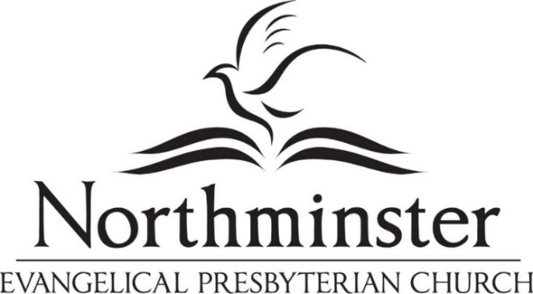

*Experiencing and sharing God’s love*

*to transform our homes, community and world.*

**13**But now I am coming to you, and these things I speak in the world, that they may have my joy fulfilled in themselves. **14**I have given them your word, and the world has hated them because they are not of the world, just as I am not of the world. **15**I do not ask that you take them out of the world, but that you keep them from the evil one.**16**They are not of the world, just as I am not of the world. **17**Sanctify themin the truth; your word is truth. **18**As you sent me into the world, so I have sent them into the world. **19**And for their sake I consecrate myself, that they also may be sanctifiedin truth.

— John 17:13-19 (ESV)

**SERMON NOTES, July 10**

**NEW TESTAMENT READING:** John 17:13-19

**SERMON*: “Truth or Consequences”***

**Series: Three Steps Toward God: Beauty, Goodness, Truth**

*Sanctify themin the truth; your word is truth.  – John 17:17*