NEWS & ANNOUNCEMENTS

**Children are welcomed in the service. A nursery is provided for infants – 4 years. Others needing childcare may leave worship after the ANTHEM.**

**YOUTH EVENTS FOR THE SUMMER**

With the end of the school year comes the end of Sunday Night Live for grades 4-12, until the fall. But that doesn’t mean we won’t have fun events and summer camp to look forward to this summer! Be sure to watch your bulletin for more information.

**ADULT SUNDAY SCHOOL**

Join us in the Fellowship Hall from 9:45-10:45 am as we explore God’s Word together and are encouraged in our walk with the Lord. Bob Mills is currently leading a series on education and the church.

**ELDERS AVAILABLE FOR PRAYER FOLLOWING WORSHIP**

In James 5:13-14 we read, “*Is anyone among you in trouble? Let them pray. Is anyone happy? Let them sing songs of praise. Is anyone among you sick? Let them call the elders of the church to pray over them and anoint them with oil in the name of the Lord*.” Each Sunday, two elders will be available in the New Song room following worship for anyone who needs or would like prayer.

**PASTOR DAVID ON STUDY LEAVE**

Please keep Pastor David in your prayers as he travels through Israel with a group of pastors for study leave. He will be back July 7 & 8, then head to the youth summer camp, Fun In The Son, in Hilton Head, South Carolina from July 10-15. He will return to the pulpit on Sunday, July 17.

**For Our Guests:**

**WELCOME TO   
NORTHMINSTER EVANGELICAL   
PRESBYTERIAN CHURCH**

We are glad you are here.  We hope the information listed on these pages will help you choose your next steps in connecting at Northminster.  If you need help finding anything or have questions, just ask an usher or the pastor.  To learn more about activities here, please pick up our newsletter from the rack in the hallway or foyer table.  You can also learn more about us on our website: [www.npcmh.com](http://www.npcmh.com), and on Facebook: [www.facebook.com/npcmh](http://www.facebook.com/npcmh)

Calendar for the Coming Week

**Today, July 3:**

**9:45 am –** Sunday School for all ages

**11:00 am –** Worship

**Tuesday, July 5:**

**12:00 pm –** Lynchburg Daily Bread Meal Distribution

**Wednesday, July 6:**

7:00 pm – Choir Practice

**Next Sunday, July 10:**

**9:45 am –** Sunday School for all ages

**11:00 am –** Worship

**12:15 pm –** Fellowship and Refreshments

­

**SERVICE FOR THE LORD’S DAY**

**July 3, 2022**

**WELCOME AND ANNOUNCEMENTS**

**PRELUDE**

Liturgist, Maggie Brockman

**CALL TO WORSHIP** — (Psalm 34:1-2, 8)

Leader: I will bless the Lord at all times;

**People: His praise shall continually be in my mouth**

Leader: My soul makes its boast in the Lord;

**People: Let the humble hear and be glad.**

Leader: Oh, taste and see that the Lord is good!

**People: Blessed is the man who takes refuge in him!**

**\*OPENING HYMN #317** All People That on Earth Do Dwell

**\* OPENING PRAYER**

**\* HYMN #26** Praise, My Soul, the King of Heaven

**PRAYER OF CONFESSION**

**Most Merciful God: The world around us is confusing. We’re being told that up is down, left is right, evil is good, and good is evil. And at times, we’ve listened to the world instead of to your Word. For these and other sins, O Lord, forgive us. Renew our battered spirits. Restore our wearied souls. Remind us, and through us remind those around us, that goodness exists because you are Good. Through Jesus Christ our Lord. Amen.**

**\*ASSURANCE OF PARDON**

**\*AFFIRMATION OF FAITH** — The Nicene Creed

Leader: Christian, what do you believe?

**People: We believe in one God the Father Almighty, Maker of heaven and earth, and of all things visible and invisible;**

**And in one Lord Jesus Christ, the only-begotten Son of God, begotten of the Father before all worlds, God of God, Light of Light, Very God of Very God, begotten, not made, being of one substance with the Father, by whom all things were made; who for us men, and for our salvation, came down from heaven, and was incarnate by the Holy Spirit of the Virgin Mary, and was made man, and was crucified also for us under Pontius Pilate. He suffered and was buried, and the third day he rose again according to the Scriptures, and ascended into heaven, and sitteth on the right hand of the Father. And he shall come again with glory to judge both the quick and the dead, whose kingdom shall have no end.**

**And we believe in the Holy Spirit, the Lord and Giver of Life, who proceedeth from the Father and the Son, who with the Father and the Son together is worshipped and glorified, who spoke by the prophets. And we believe one holy catholic and apostolic Church. We acknowledge one baptism for the remission of sins. And we look for the resurrection of the dead, and the life of the world to come. Amen.**

**SPECIAL MUSIC** Liz Boothe, Organist

*Variations on "My Country, 'Tis of Thee"*by John Barr

**WORSHIPING GOD WITH OUR TITHES AND OFFERINGS**

**Offertory**

**\*Offertory Response — “Doxology”**

***Praise God from whom all blessings flow;***

***Praise Him all creatures here below;***

***Praise Him above, ye heavenly host:***

***Praise Father, Son, and Holy Ghost. Amen.***

**\*Prayer of Dedication**

**OLD TESTAMENT READING:**  Psalm 100

**NEW TESTAMENT READING:** Mark 10:17-18

*Pastor: The Word of the Lord*

***People: Thanks be to God***

**SERMON*: “Why Me?”***

**Series: Three Steps Toward God: Beauty, Goodness, Truth**

*For the LORD is good… – Psalm 100:5*

**SACRAMENT OF HOLY COMMUNION**

**Words of Introduction, Invitation, Institution**

**Partaking of the Communion Elements**

**Closing**

**\*CLOSING HYMN #216** Beneath the Cross of Jesus

**\*BENEDICTION**

**\*POSTLUDE**

***\*Please Stand*** Copyright License #254910

***Pastor,* David Garrison**

**ELDERS Bob Mills,** ***Director of Music***

**Ron Reyburn, Liz Boothe, *Organist***

**John Lange, Liz Boothe Sharon Bryant, *Sunday School***

**Sharon Bryant, Judy Reyburn  *Superintendent* Maggie Brockman Kristin Kidd, *Treasurer***

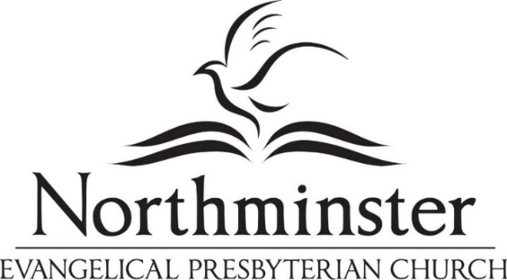

*Experiencing and sharing God’s love*

*to transform our homes, community and world.*

**100**Make a joyful noise to the Lord, all the earth!  
**2**    Serve the Lord with gladness!  
    Come into his presence with singing!

**3**Know that the Lord, he is God!  
    It is he who made us, and we are his;[[a](https://www.biblegateway.com/passage/?search=Psalm%20100&version=ESV#fen-ESV-15512a)]  
    we are his people, and the sheep of his pasture.

**4**Enter his gates with thanksgiving,  
    and his courts with praise!  
    Give thanks to him; bless his name!

**5**For the Lord is good;  
    his steadfast love endures forever,  
    and his faithfulness to all generations.

— Psalm 100 (ESV)

**17**And as he was setting out on his journey, a man ran up and knelt before him and asked him, “Good Teacher, what must I do to inherit eternal life?” **18**And Jesus said to him, “Why do you call me good? No one is good except God alone.”

* — Mark 10:17-18

**SERMON NOTES, July 3**

**OLD TESTAMENT READING:**  Psalm 100

**NEW TESTAMENT READING:** Mark 10:17-18

**SERMON*: “Why Me?”***

**Series: Three Steps Toward God: Beauty, Goodness, Truth**

*For the LORD is good… – Psalm 100:5*